**Azure Active Directory**

Write a client application to authenticate based on OAuth grant flow.

**Azure Active Directory** (aka **Azure AD**) is a fully managed multi-tenant service from Microsoft that offers identity and access capabilities for applications running in Microsoft **Azure** and for applications running in an on-premises environment.

Azure AD uses OAuth 2.0 to enable you to authorize access to web applications and web API’s in your Azure AD tenant.

I have created my own Active directory called “TestActivedirectory”, below screen shots shows how to create Azure active Directory.

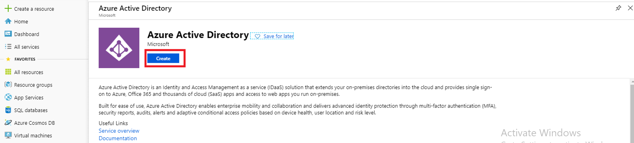

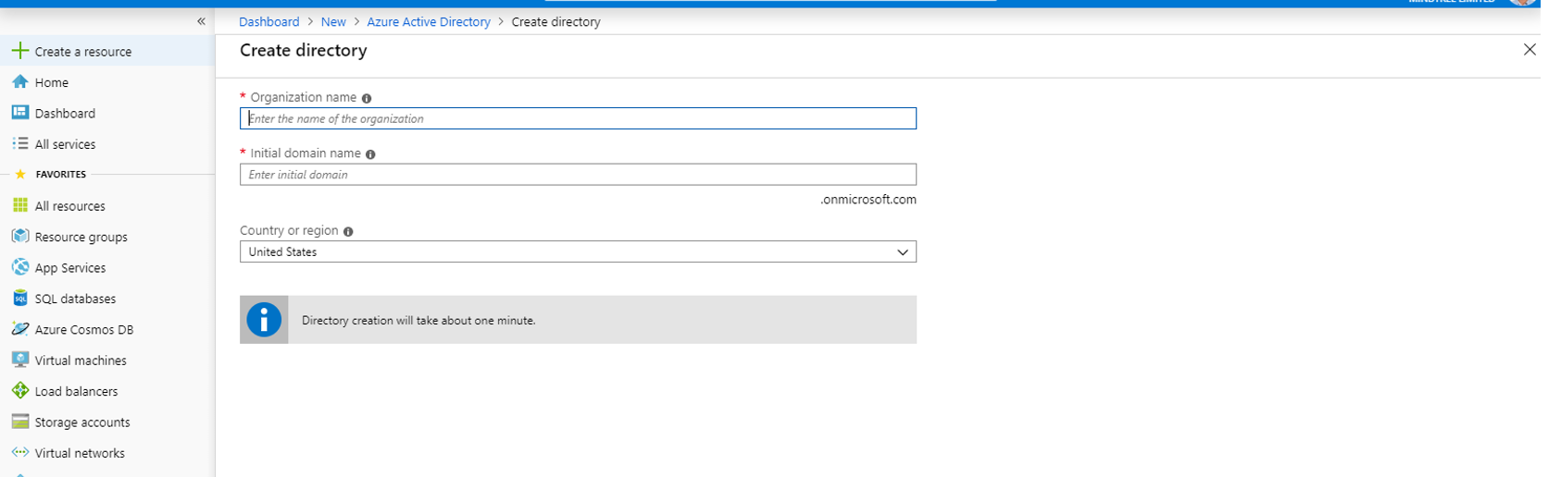

Fill all the required details and click the crate button on the bottom of the below screen.

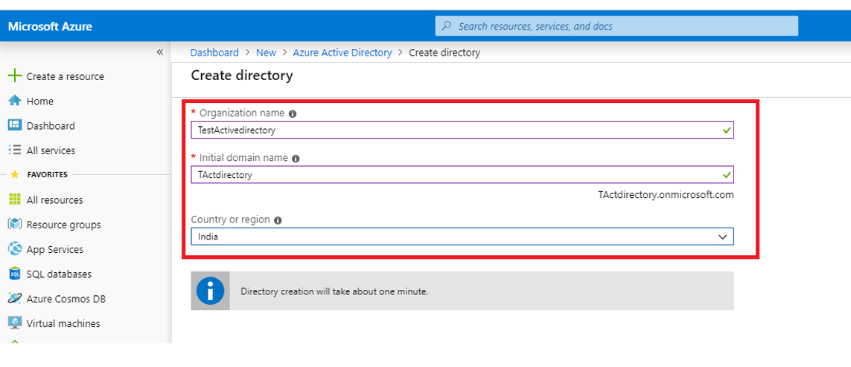

Once your active directory is created we can view you directory by using the “Switch directory“ option. Below screen shots show how to navigate your directory

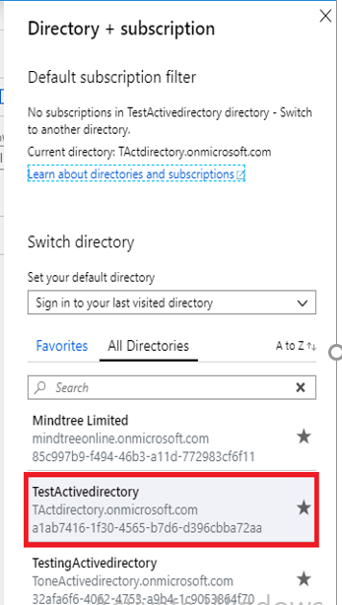

Later using the users option create your own users, below screen shots show the same.

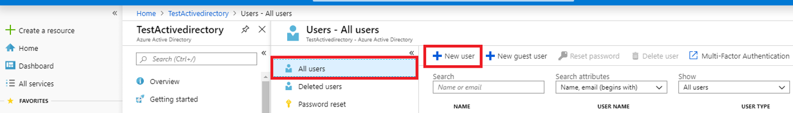

APP Registrations:

To register you own app follow the below screen shots

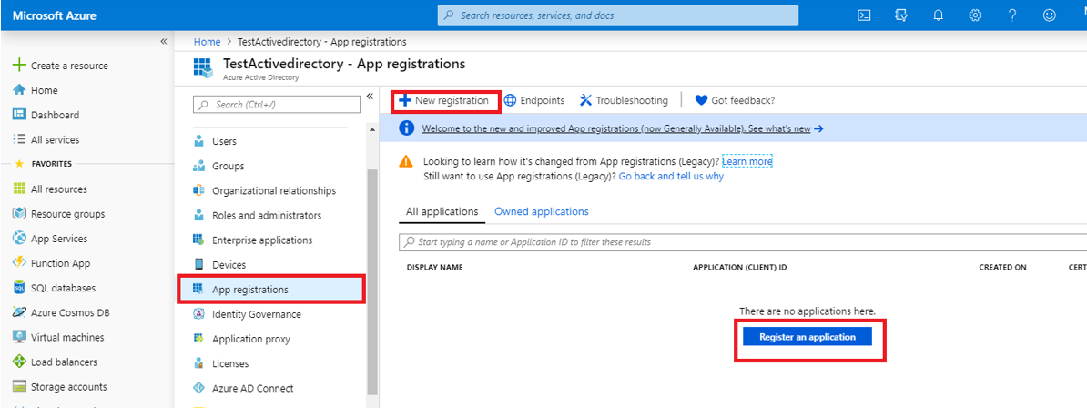

Fill all the required details and click on Register Button as per the below screen shot.

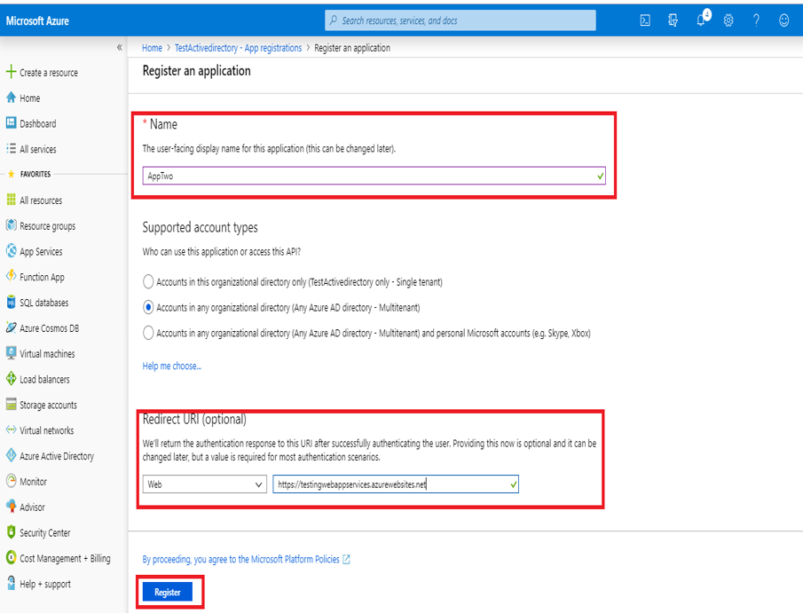

I have registered two App’s “Appone” and “AppTwo”. Below screen shots show how to fill the Branding and Authentication details.

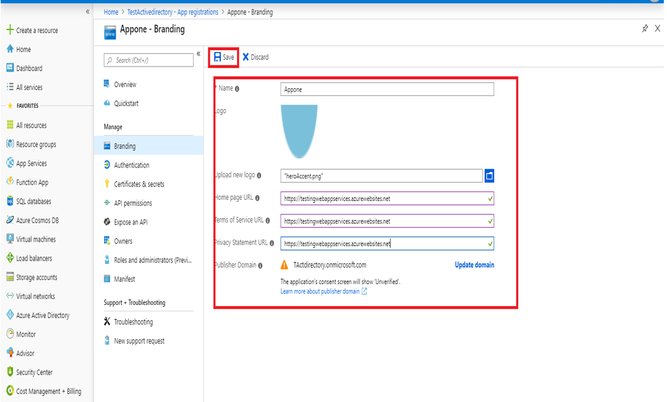

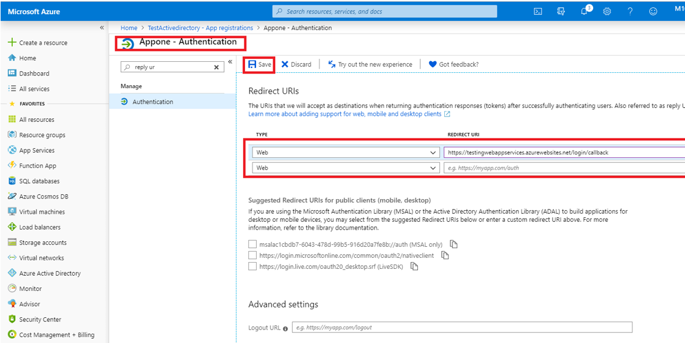

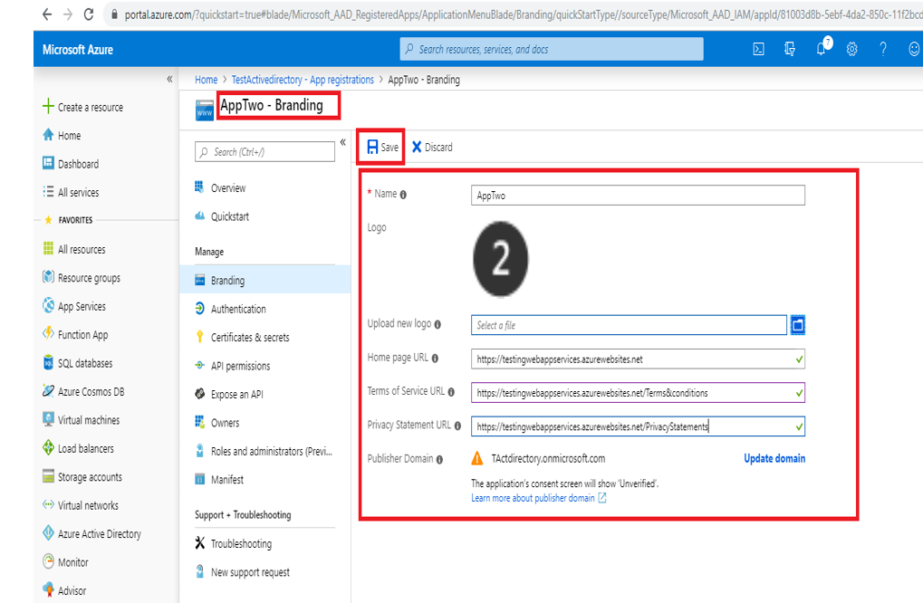

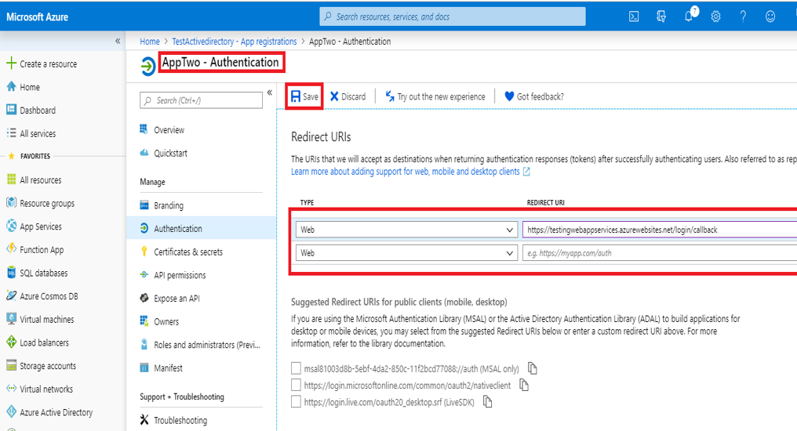

As mentioned above I have created applications in my default directory(Mindtree). Configured that application with the azure active directory called Appone and AppTwo. “a1ab7416-1f30-4565-b7d6-d396cbba72aa” is my Active directory ID.

Following are the url’s for which I have given access in my Active Directory Appone and AppTwo.

<https://testingappone.azurewebsites.net>

<https://testingwebappservices.azurewebsites.net>

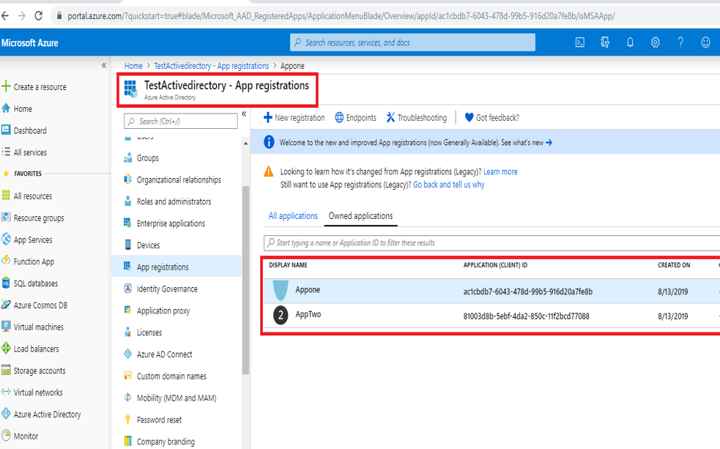

Using the following url “https://sts.windows.net/ a1ab7416-1f30-4565-b7d6-d396cbba72aa” and application ID which is created in the Active Directory are used to configure the application services.

Following are the app in in default MINDTREE directory.



<https://testingwebappservices.azurewebsites.net/login/callback> is the call back url configured in the default MINDTREE directory.